Student Performance Data Analytics Project
You have been employed as a Junior Data Analyst by the National Education Performance Monitoring Agency. The agency has collected academic records from 1,500 students from different schools. The dataset contains numerous inconsistencies, missing values, duplicate records, invalid entries, and formatting errors. Your task is to clean, analyze, visualize, and interpret the dataset using R.
Section A: Data Import and Understanding

1. Import the student performance dataset into R and verify that the data has been loaded successfully.
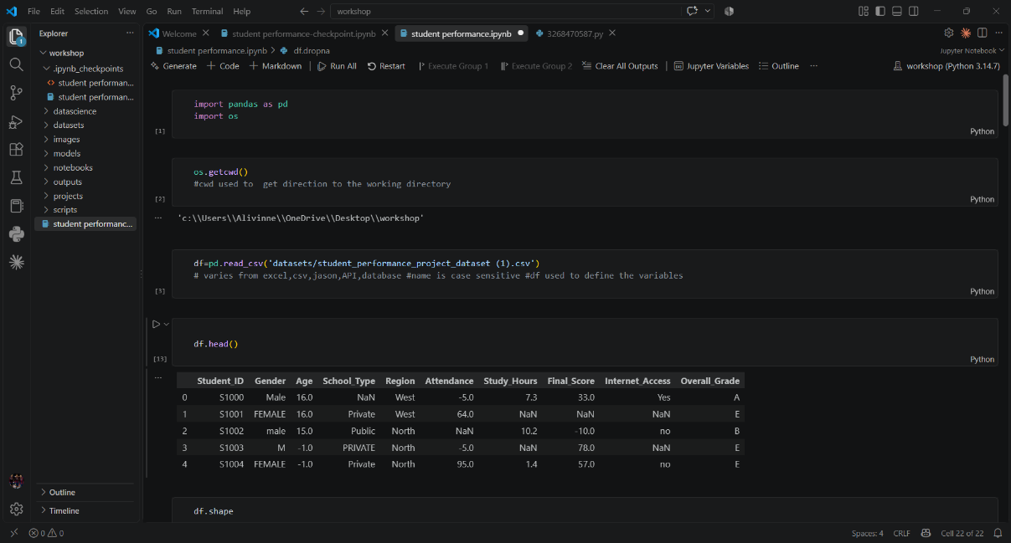

2. Examine the structure, dimensions, variable names, and data types of the dataset using appropriate R 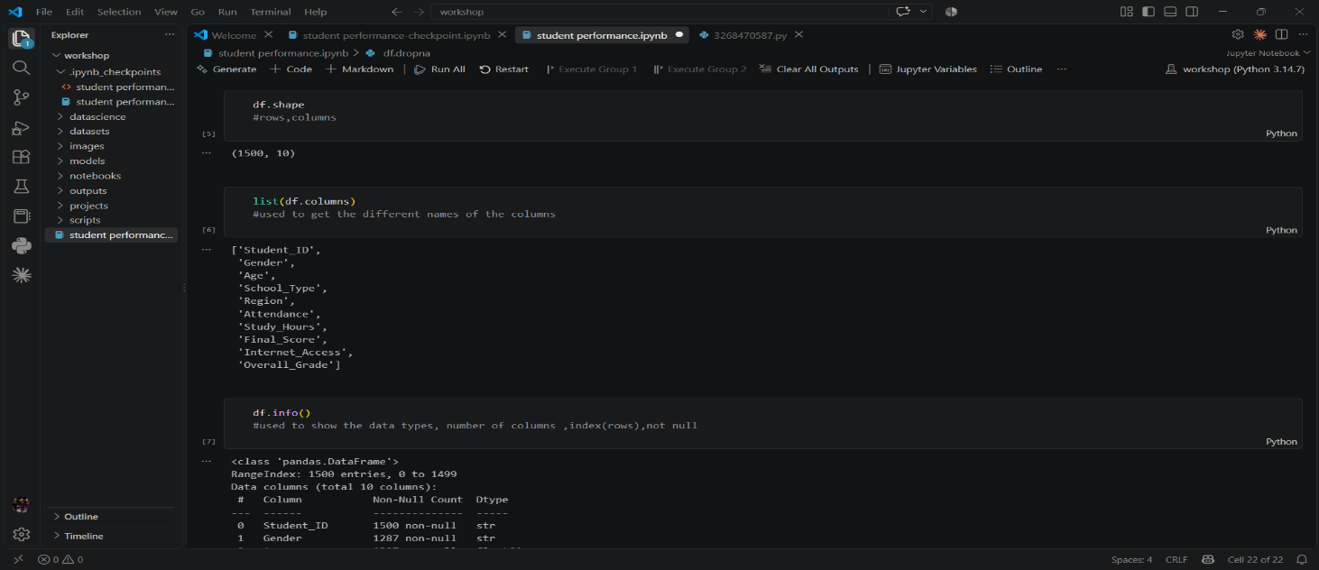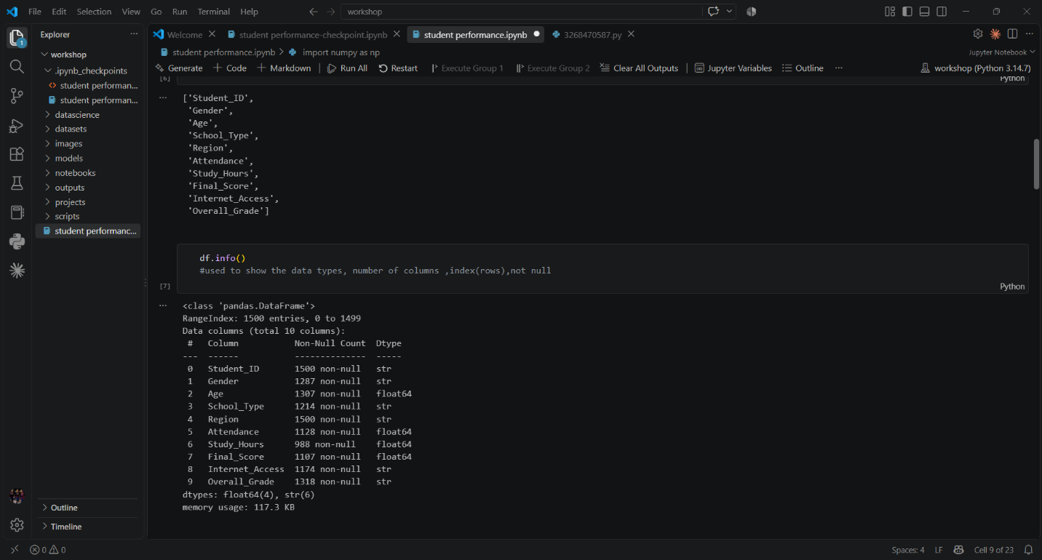

3. Explore the dataset to identify the types of variables available for analysis.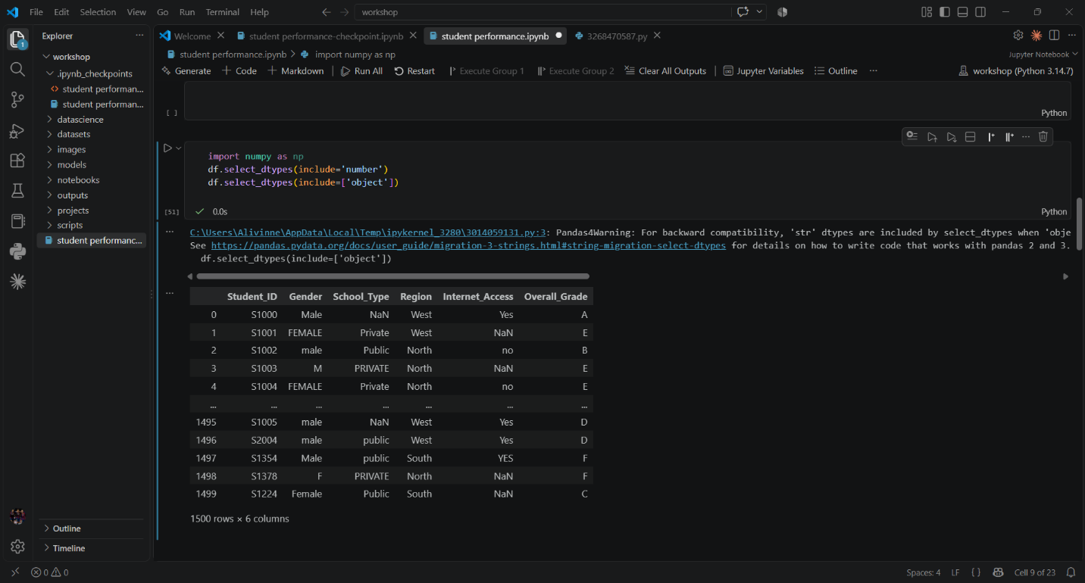

4. Produce summary statistics to gain an initial understanding of the dataset.
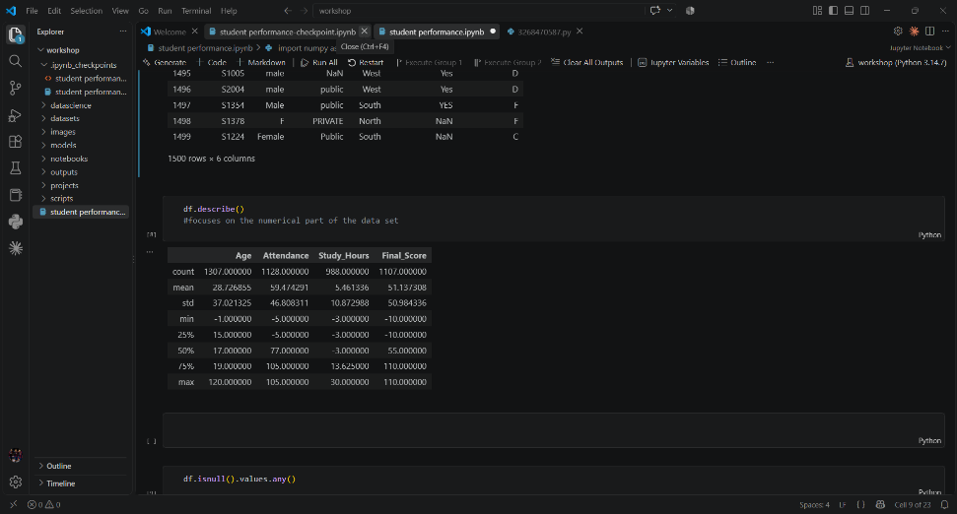

Section B: Data Cleaning and Validation

5. Clean and validate the student performance dataset by identifying and correcting missing values using appropriate R techniques.
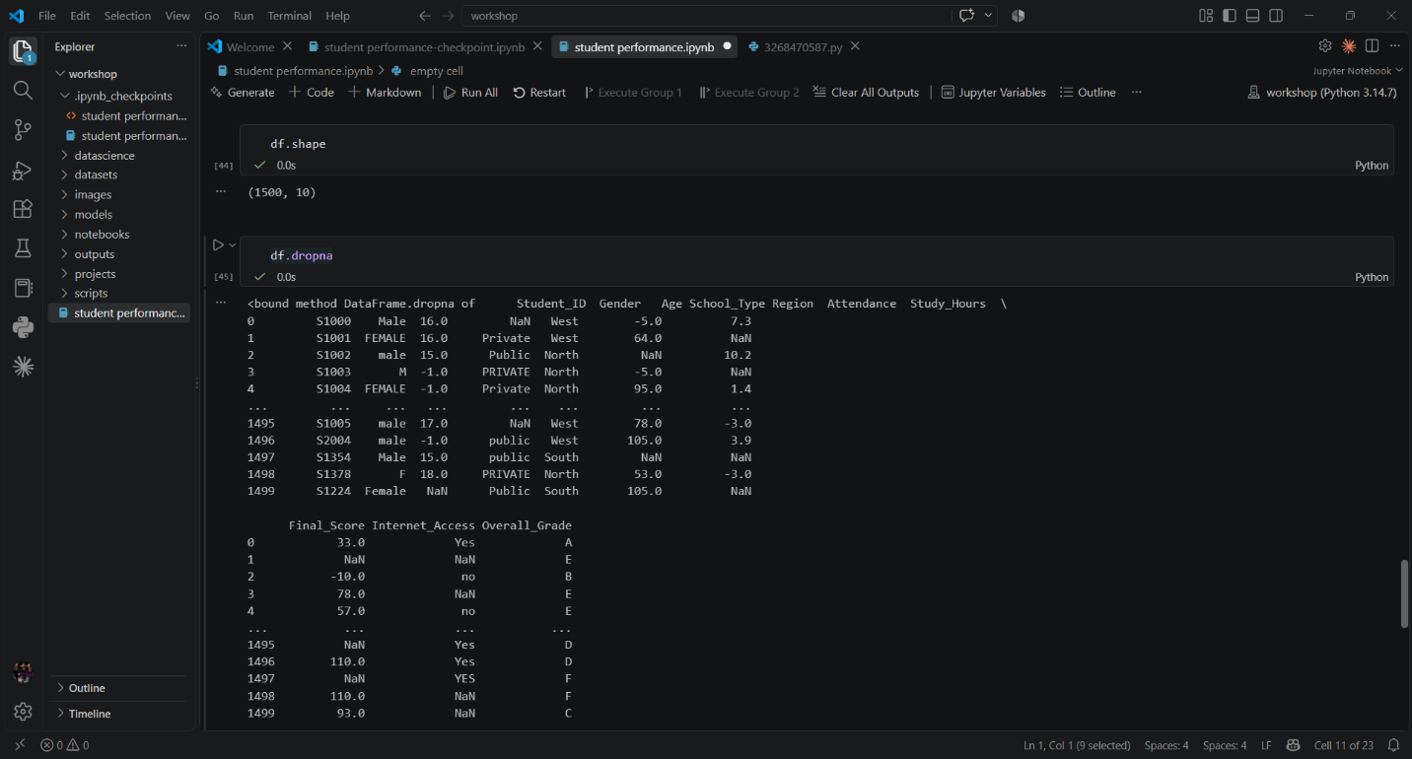

6. Identify, validate, and remove duplicate student records while maintaining data integrity.

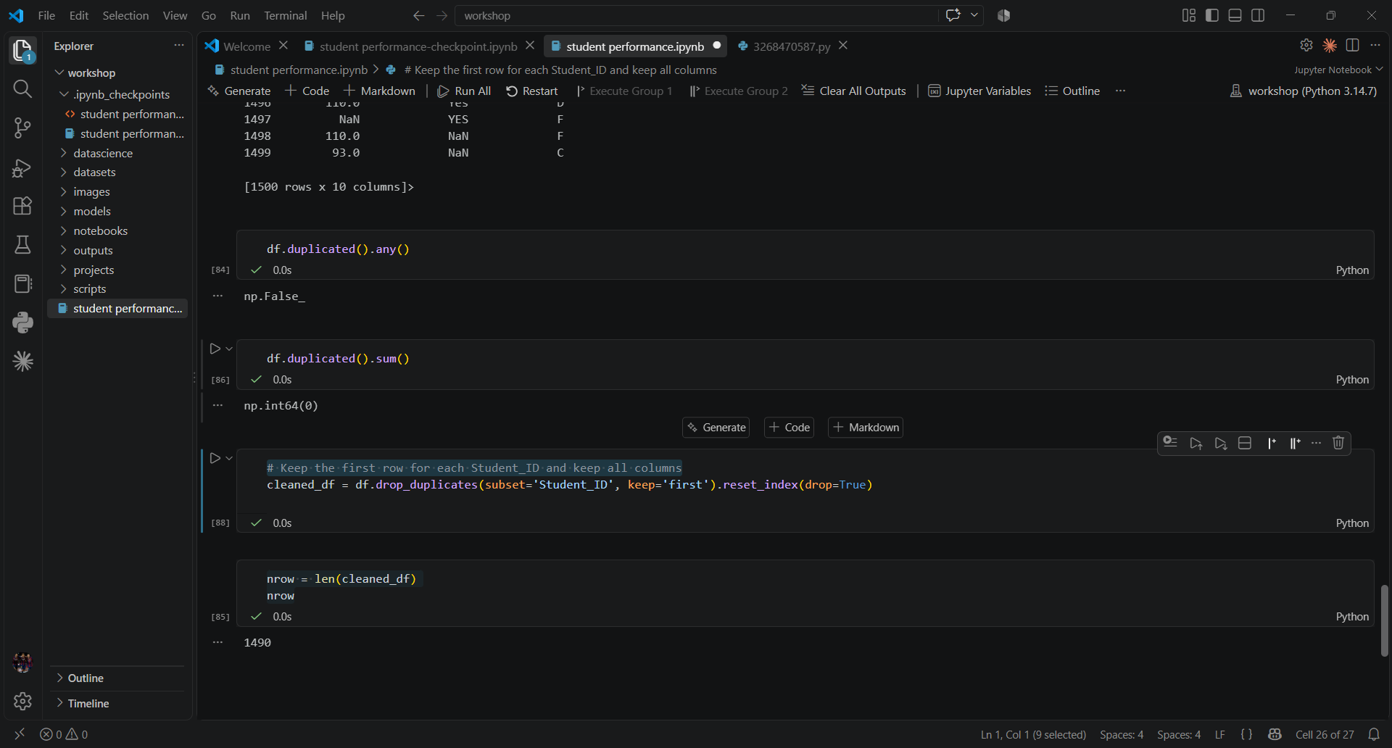

7. Validate student demographic information by identifying invalid ages, incorrect gender values, and inconsistent categorical entries.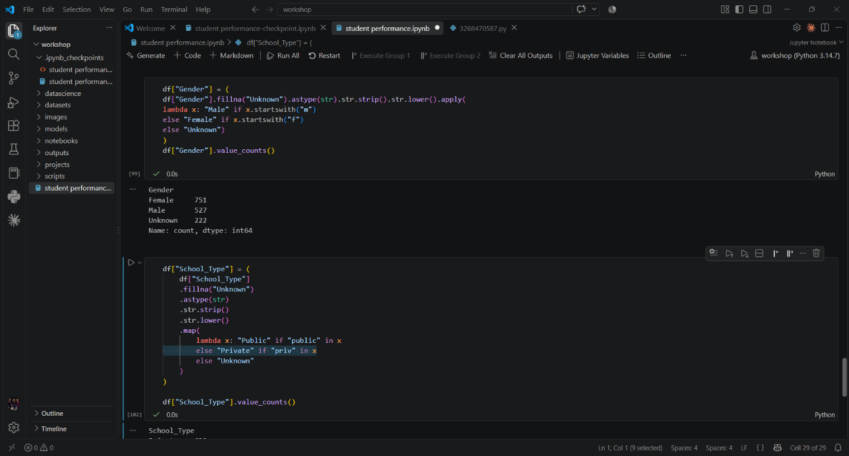

8. Standardize categorical variables such as gender, school type, internet access, scholarship status, and extracurricular participation. 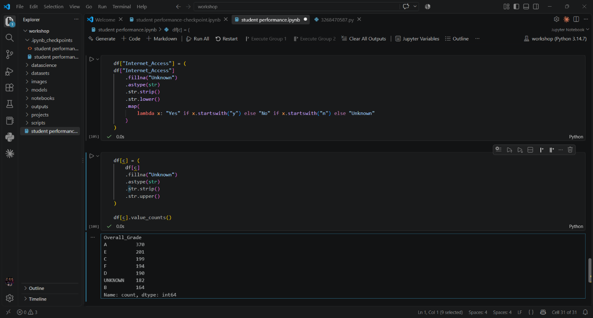

9. Detect and correct inconsistent text formatting, including unnecessary spaces, mixed letter cases, and spelling inconsistencies. 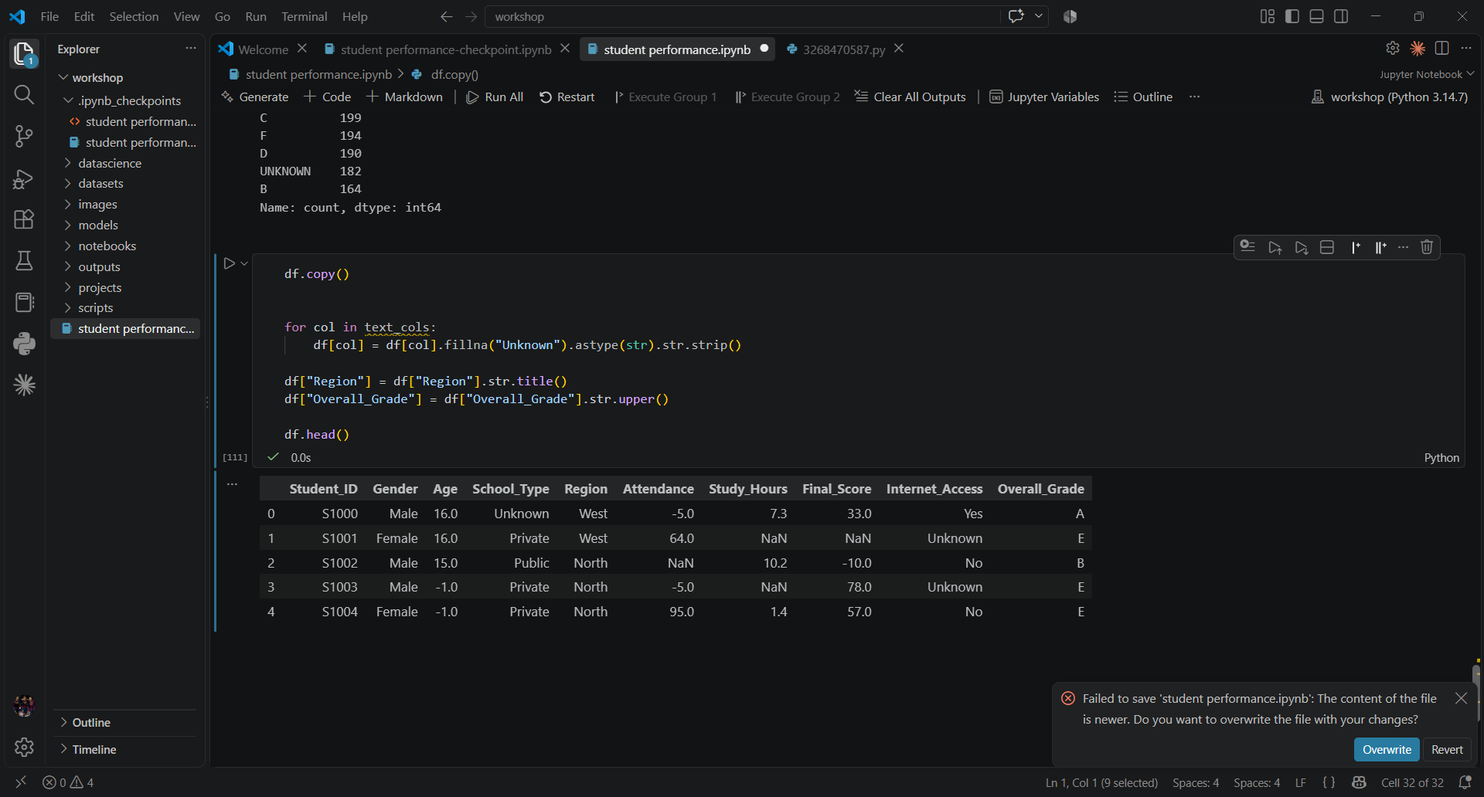

10. Convert variables into appropriate data types to facilitate accurate statistical analysis. 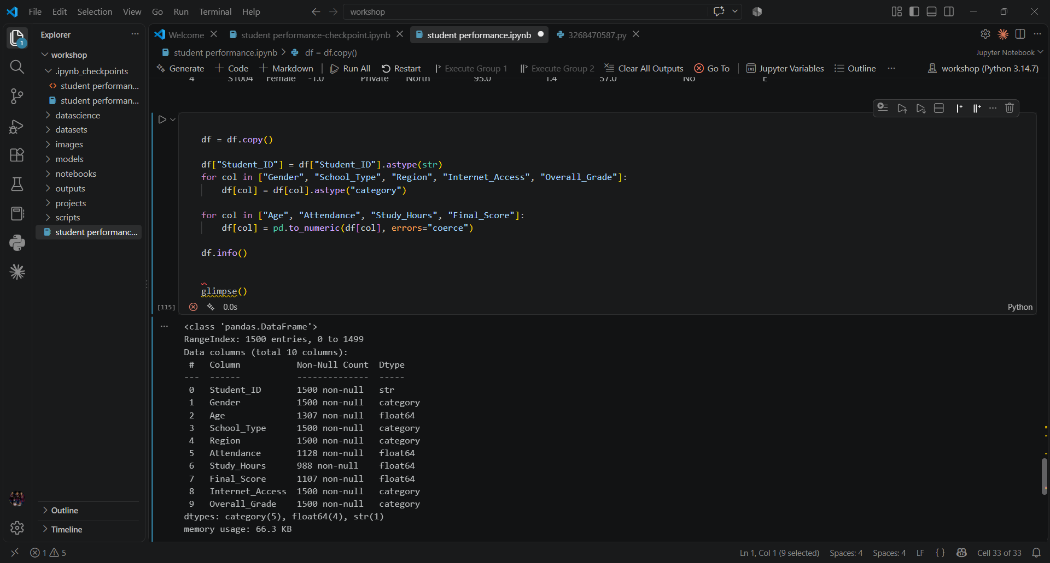

11. Identify and validate unrealistic numerical values such as attendance percentages above 100%, negative study hours, invalid examination scores, and impossible absence records. 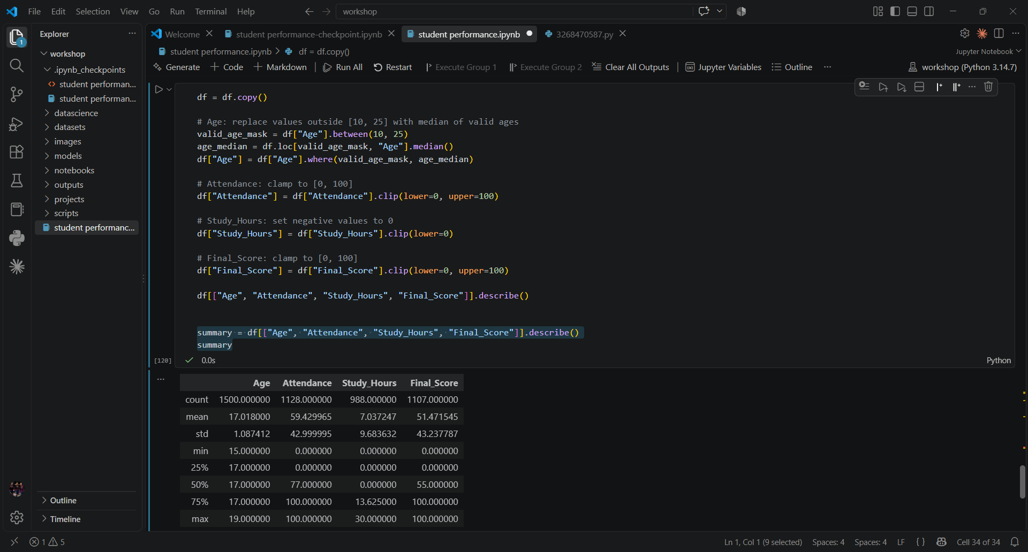

12. Detect and appropriately handle outliers in continuous variables using suitable statistical techniques.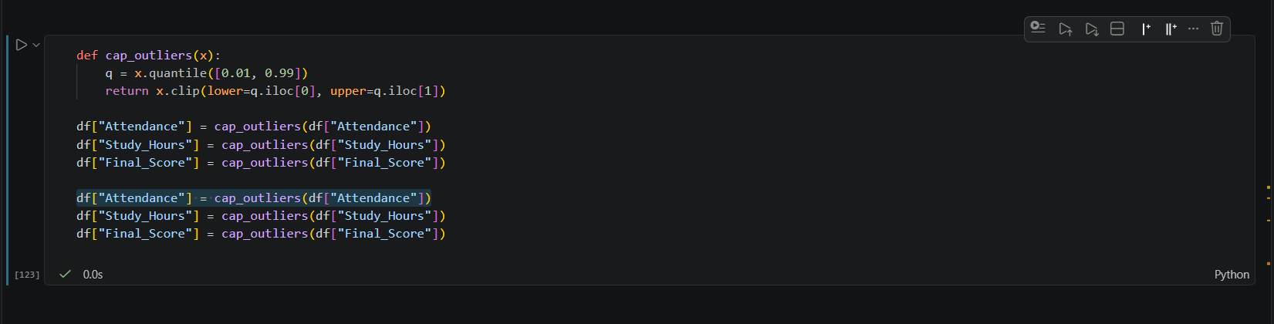

13. Produce a cleaned and validated dataset ready for analysis and export it as a new CSV file.
